From your start menu press the windows key + w to pull up your menu
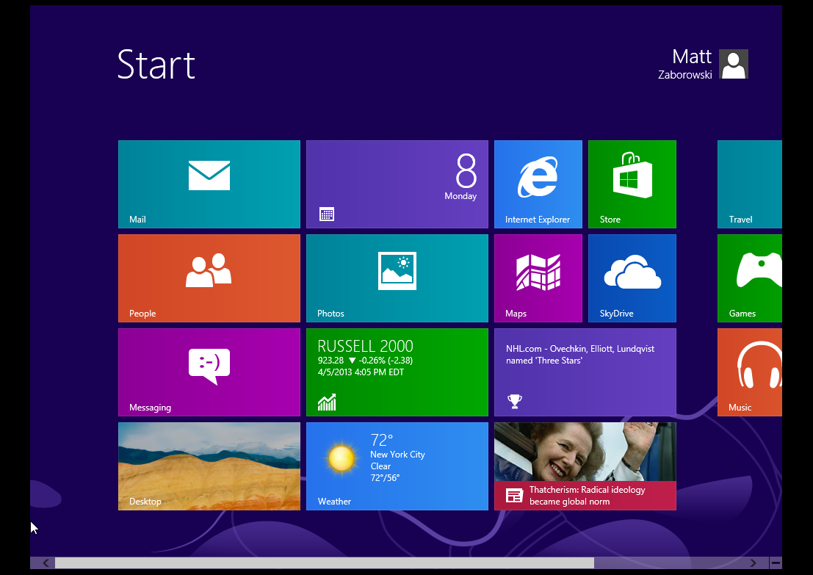
Click on Store and do a search for Citrix Receiver
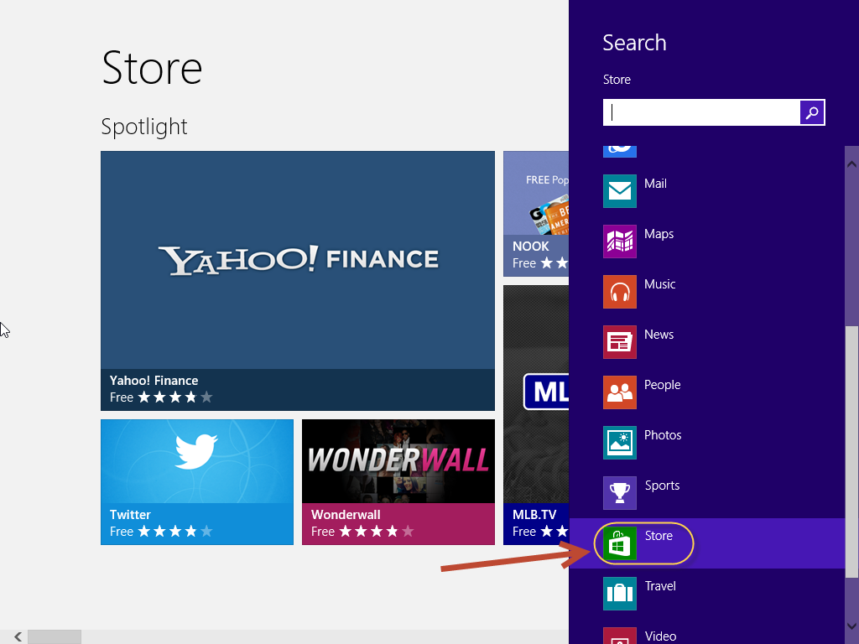

Select the Receiver
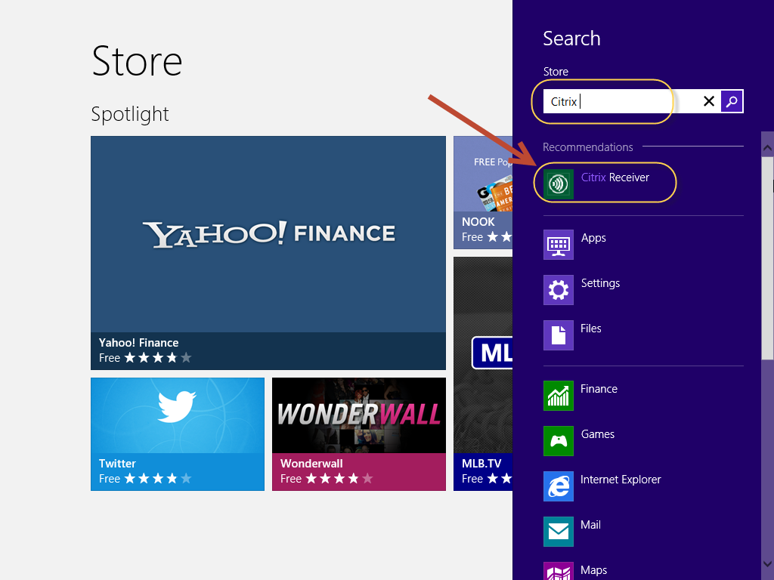
Run the installer
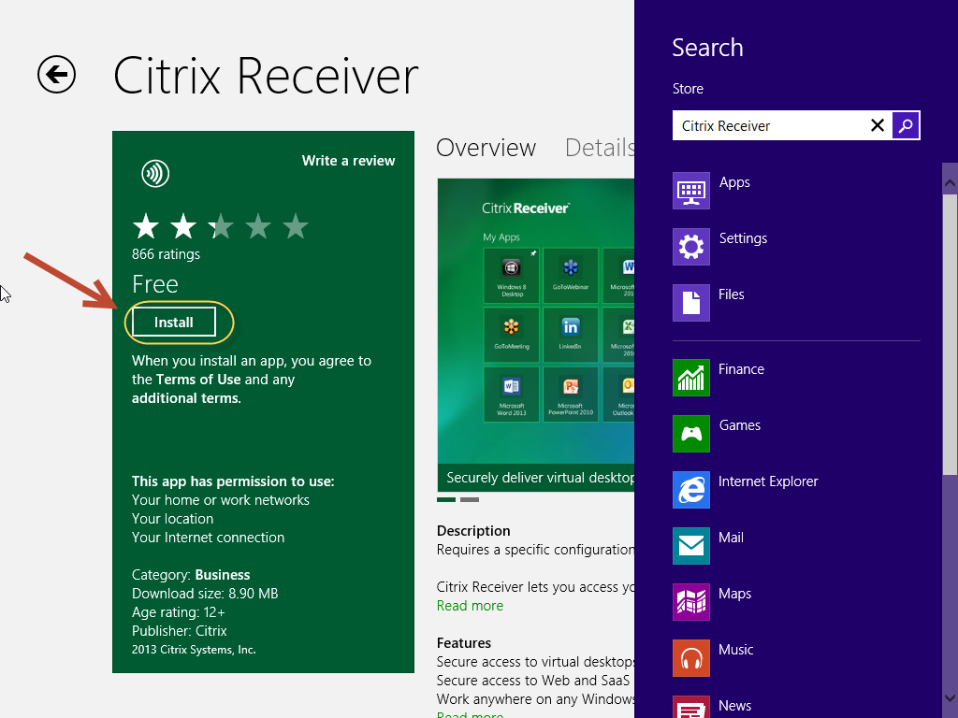

Once the installer finishes click on the following tile
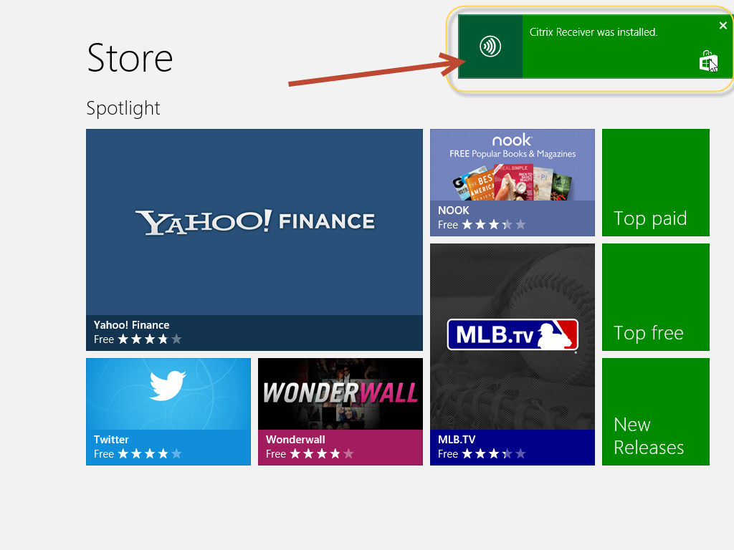
Now fill in the information. Do not put your work email address into the field. Type the following: HTTPS://tsm.ttx.com
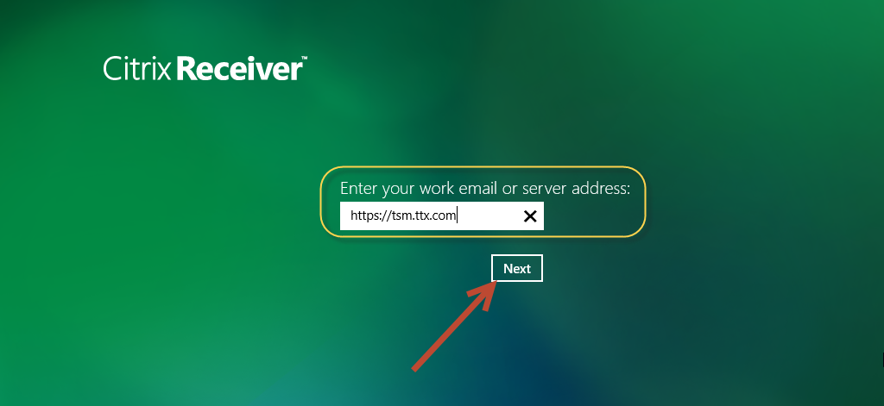
Fill in the information with your network log in. ttxdom01\Username and Password
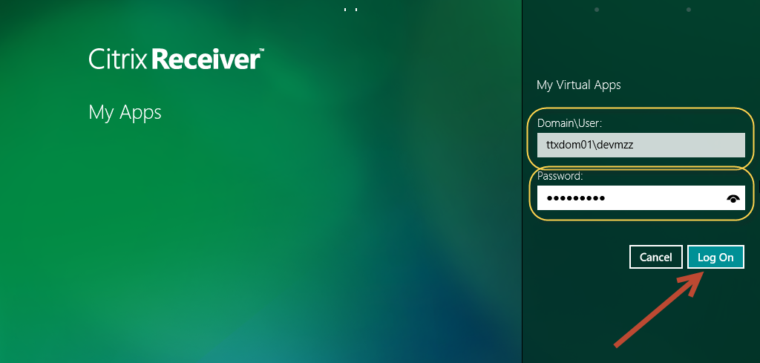
When you need to get back to citrix press windows key + w and click on apps, Citrix will be in the list.
